**Learning Objectives:**

* State the concepts of dynamic analysis of four bar mechanisms
* Understand the significance of parameter and select the variable accordingly.
* Calculate the velocity, acceleration and force acting on each link.
* Examine the calculated values with the simulation results
* Evaluate how change in length, angle and driving force results in change of acceleration, velocity and work done by the mechanism

THEORY:

A four bar link mechanism or linkage is the most fundamental of the plane kinematics linkages. It is a much-preferred mechanical device for the mechanization and control of motion due to its simplicity and versatility.[[1](http://engineering.myindialist.com/2009/lab-manual-study-of-inversions-of-4-bar-mechanism-single-and-double-slider-crank-mechanism/#.XT57R-gzZPY)] Basically, it consists of four rigid links which are connected in the form of quadrilateral by four pin joints. If a link completes its full rotation then it’s a crank motion and if it oscillates, the link opposite to the fixed link is the coupler and adjacent to fixed link are input and output link.

The dynamic analysis of the four bar mechanism is covered after understanding the kinematic analysis since the acceleration of the links are required to calculate the forces on the link. The analysis involves the offset analysis, acceleration of CG, forces on each link of four bar mechanism, with the help of position diagram, velocity and acceleration diagram.

**Equations/formulas:**

**Dynamic force Analysis of a 4 – link mechanism.**

OABC is a 4–bar mechanism. Link 2 rotates with constant angular velocityω2. G2, G3& G4 are the center of gravity and M1, M2& M3 the masses of links 1, 2 & 3 respectively.

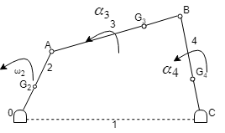

What is the torque required, which, the shaft at o must exert on link 2 to give the desired motion?

1. Draw the velocity & acceleration polygons for determine the linear acceleration of G2, G3& G4.
2. Magnitude and sense of α3&α4 (angular acceleration) are determined using the results of step 1.

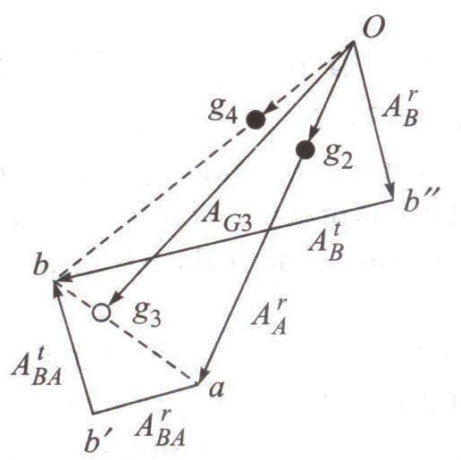

**To determine inertia forces and couples**

**Link 2**

F2 = accelerating force (towards O)

*Fi*2= inertia force (away from O)

Since ω2 is constant, α2 = 0 and no

inertia torque involved.

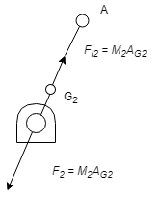

***Link 3***

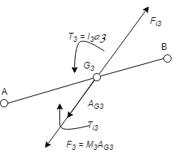

Linear acceleration of G3 (i.e., AG3) is in the direction of *Og*3 of acceleration polygon.

*F*3= accelerating force

Inertia force *Fi*3' acts in opposite direction. Due to α3, there must be a resultant torque T3 = I3α3 acting in the sense of α3 (I3 is MMI of the link about an axis through G3, perpendicular to the plane of paper). The inertia torque *Ti*3 is equal and

opposite to T3.

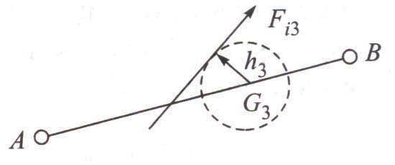

|  |  |  |  |  |  |  |  |  |  |  |
| --- | --- | --- | --- | --- | --- | --- | --- | --- | --- | --- |
| *F* | can replace the inertia force | *F* ' | and inertia torque *T* | . *F* is tangent to circle of radius h3 | | | | | |  |
| *i* 3 |  | *i* 3 | *i* 3 | *i* 3 |  |  |  |  |  |  |
| from G3, on the top side of it so as to oppose the angular accelerationα3. | | | | | *h*3 | *I* | 3*α* | 3 |  |  |
|  |  |  |  |  |

*M* 3 *AG*3

**Link 4**

|  |  |  |  |  |
| --- | --- | --- | --- | --- |
| *h*4 | *I* | 4*α* | 4 |  |
|  |  |  |  |

*M* 4 *AG*4

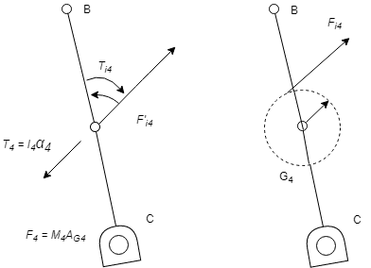G4

SOURCE: <https://www.academia.edu/37828056/Chapter_-2_DYNAMIC_FORCE_ANALYSIS>

RESFERENCE:

[1] <http://engineering.myindialist.com/2009/lab-manual-study-of-inversions-of-4-bar-mechanism-single-and-double-slider-crank-mechanism/#.XT57R-gzZPY>

[2] <https://www.academia.edu/37828056/Chapter_-2_DYNAMIC_FORCE_ANALYSIS>